Employee Assistance Program
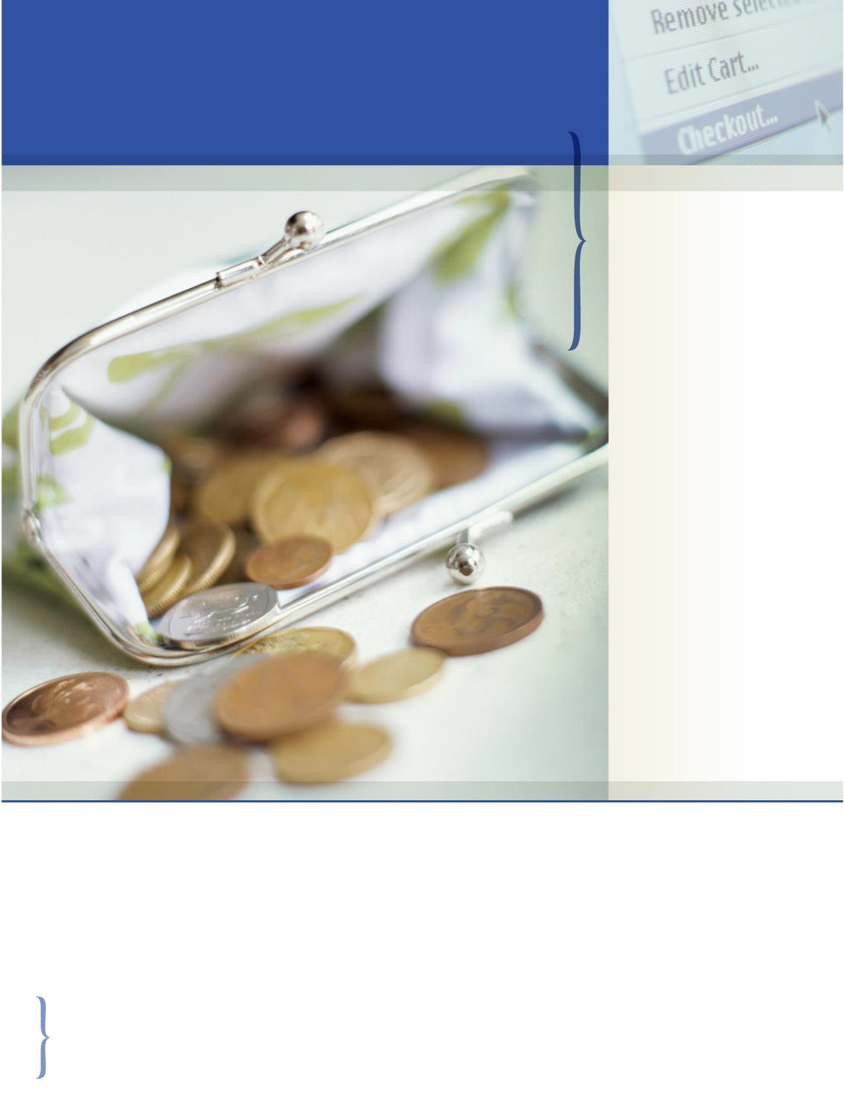

SAVINGS CENTER

FEATURES INCLUDE:

- Through the Savings Center, save on such items as: hotels, cars, flights, major appliances, technology, clothing, restaurants, movie tickets and more!
- To take advantage of these discounts, go to My Portal Login > Work-Life and click on the Savings Center
tab in the right-hand column
- Use the company name Workplace Options US and company code "EAP"
- The program offers a wide array of discounts from leading name-brand retailers too!

Bills, health care, retirement savings, and taxes all take enough out of our paychecks already. To help you stretch your dollar, you and your family have access to a free online benefit through the Savings Center - Perks At Work. When you log on to the Savings Center, you can shop quality name brands at discounts of 25 to 70 percent off regular retail prices in addition to discounts to restaurants, entertainment and more! You can also earn points to use for future purchases. Register for free on your employee assistance website.

TOLL-FREE: 800-633-3353

WEBSITE: www.mygroup.com > My Portal Login > Work-Life
> USERNAME: organization specific • PASSWORD: guest > Savings Center

